

Undergraduate Lab Report

Course Title: Experiment of Computer Organization
Course No: 60080014
Student Name: 蒋云翔
Student No: 2022102330
School: 暨南大学
Department: 国际学院
Major: CST
Instructor： SUN Heng

Academic Year:2023~2024,Semester : 1st [ √ ] 2nd[ ]

Academic Affairs Office of Jinan University
Date (dd/mm/yyyy)___17/10/2023_____
Computer Organization Lab List
Student Name: 蒋云翔 Student No: 2022102330

ID | Lab Name | Type
1 | Number Storage Lab | Individual
2 | Manipulating Bits | Individual
3 | Simulating Y86-64 Program | Individual
4 | Performance Lab | Team
5 | A Simple Real-life Control System | Team
6 | System I/O | Individual
Undergraduate Lab Report of Jinan University
Course Title Experiment of Computer Organization Evaluation
Lab Name Manipulating Bits Instructor SUN Heng
Lab Address 116
Student Name 蒋云翔 Student No 2022102330
College 暨南大学
Department 国际学院 Major CST
Date 17 / 10 / 2023 Morning / Afternoon
- Introduction

The purpose of this lab is to become more familiar with bit-level representations and arithmetic of integers in chapter 2. You'll do this by solving a series of programming puzzles.
- Lab Instructions or Steps

Start by copying bits.c to a directory on a Linux machine in which you plan to do your work. You will be modifying this file.

The bits.c file contains a skeleton for each of the 5 programming puzzles. Your assignment is to complete each function skeleton using only straightline code for the integer puzzles (i.e., no loops or conditionals) and a limited number of C arithmetic and logical operators. Specifically, you are only allowed to use the following eight operators: ! ~ & ^ | + << >>

- Lab Device or Environment
VMware workstation pro & Ubuntu16.04
- Results and Analysis
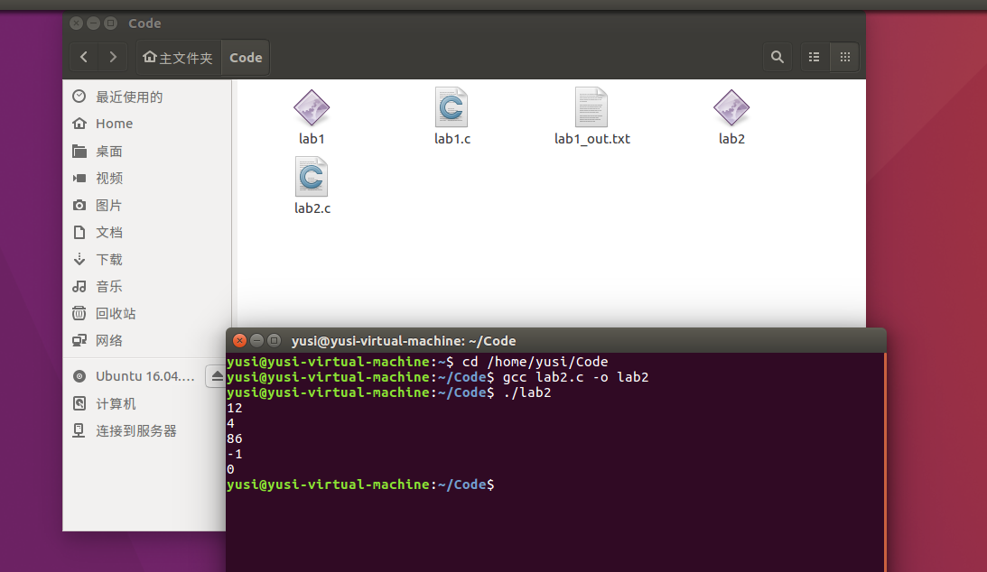
- Appendix (Program Code)
#include<stdio.h>

//STEP 2: Modify the following functions according the coding rules.

/*
* pow2plus4 - returns 2^x + 4, where 0 <= x <= 31
* Legal ops: + <<
*/
int pow2plus4(int x) {
return (1 << x) + 4;
}

/*
* bitAnd - x&y using only ~ and |
* Example: bitAnd(6, 5) = 4
* Legal ops: ~ |
*/
int bitAnd(int x, int y) {
return ~(~x | ~y);
}

/*
* getByte - Extract byte n from word x
* Bytes numbered from 0 (LSB) to 3 (MSB)
* Examples: getByte(0x12345678,1) = 0x56
* Legal ops: & << >>
*/
int getByte(int x, int n) {
return (x >> (n << 3)) & 0xFF;
}

/*
* negate - return -x
* Example: negate(1) = -1.
* Legal ops: ~ +
*/
int negate(int x) {
return ~x + 1;
}

/*
* isPositive - return 1 if x > 0, return 0 otherwise
* Example: isPositive(-1) = 0.
* Legal ops: ! | >>
*/
int isPositive(int x) {
return !((x >> 31) | !x);
}

int main()
{
printf("%d\n", pow2plus4(3));
printf("%d\n", bitAnd(6, 5));
printf("%d\n", getByte(0x12345678, 1));
printf("%d\n", negate(1));
printf("%d", isPositive(-1));
}

